BANK MANAGEMENT SYSTEM

1) 2)

K.TEJESWAR REDDY

CSE

CLOUD COMPUTING

SRM Kattankulathur Chennai,India [tk9643@srmist.edu.in](mailto:tk9643@srmist.edu.in)

C.V AKHILESH

CSE CLOUD COMPUTING

SRM Kattankulathur Chennai,India

[ca1425@srmist.edu.in](mailto:ca1425@srmist.edu.in)

3)G.YASWANTH SIVA KUMAR

CSE CLOUD COMPUTING

SRM Kattankulathur Chennai,India [yg3574@srmist.edu.in](mailto:yg3574@srmist.edu.in)

1. *ABSTRACT*— THE BANK MANAGEMENT SYSTEM IS A SOPHISTICATED SOFTWARE SOLUTION

METICULOUSLY CRAFTED TO ELEVATE THE EFFICIENCY AND SAFETY OF BANKING OPERATIONS. IT ENCOMPASSES FUNCTIONS SUCH AS CUSTOMER AND ACCOUNT MANAGEMENT, TRANSACTION PROCESSING, AND ROBUST SECURITY MEASURES. THIS SYSTEM EMPOWERS BANKS TO EFFECTIVELY HANDLE CUSTOMER DATA, INITIATE AND CONCLUDE ACCOUNT ACTIVITIES, AND EXECUTE A VARIETY OF FINANCIAL TRANSACTIONS, ALL WHILE UPHOLDING DATA PROTECTION THROUGH AUTHENTICATION, ENCRYPTION, AND ACCESS CONTROLS. MOREOVER,

IT COMES WITH REPORTING AND ANALYTICAL CAPABILITIES, ALLOWING THE CREATION OF FINANCIAL STATEMENTS AND VALUABLE CUSTOMER INSIGHTS. THE INCLUSION OF ONLINE AND MOBILE BANKING FEATURES FURTHER ENRICHES THE CUSTOMER EXPERIENCE, ENSURING ACCESSIBILITY AND CONVENIENCE. IN TODAY'S EVER-CHANGING

BANKING ENVIRONMENT, THE BANK MANAGEMENT

SYSTEM IS ESSENTIAL FOR MAINTAINING OPERATIONAL EXCELLENCE, PROVIDING TOP-TIER CUSTOMER SERVICE, AND ADHERING TO STRINGENT SECURITY STANDARDS. WITH ITS USER-FRIENDLY INTERFACE AND POWERFUL FUNCTIONALITY, IT STREAMLINES BANKING PROCESSES, REDUCES OPERATIONAL ERRORS, AND ENHANCES OVERALL PRODUCTIVITY. THIS TECHNOLOGY ENSURES BANKS CAN ADAPT TO THE DYNAMIC FINANCIAL LANDSCAPE, MEET CUSTOMER EXPECTATIONS, AND REMAIN COMPETITIVE IN THE DIGITAL ERA.

**Keywords—template, Scribbr, IEEE, format**

1. **INTRODUCTION**

The project titled "Bank Management System" is an automated telecommunications tool designed to offer customers of a financial institution access to financial transactions in a public setting, eliminating the need for human clerks or bank tellers. With thousands of transactions occurring daily across numerous banks and thousands of users relying on the banking system in their daily lives, the need for additional banks and staff increases, resulting in more manual work and heightened security risks associated with larger sums of money being stored in banks.

However, by implementing an advanced computerized banking system, the necessity for opening additional branches can be eliminated, reducing the workforce required

while also automatically storing a significant amount of information on the banking server. A fundamental requirement for any banking system is authenticity and validation. A well-designed system should be able to authenticate and validate users, enabling them to conduct various virtual transactions quickly and securely from anywhere at any time.

A key component of this authentication is the customer account number, which is essential for recognizing individuals during transactions such as deposits, withdrawals, money transfers, linking Aadhar cards to accounts, and changing account locations from one branch to another within the same bank. In everyday life, the banking system plays a pivotal role, serving as a crucial tool for the global economy and contributing significantly to a country's development and economic strength.

In the context of banking, a transaction refers to the execution of a program that carries out administrative or real- time functions, often involving shared data sources. These transactions are typically performed on behalf of banking users with accounts at the respective bank. The program executes these transactions automatically, ensuring that they are carried out accurately while checking for compliance with all relevant conditions. This automated and secure process helps maintain the integrity of the calculations involved in each transaction.

Our project also offers the convenience of linking Aadhar cards to account numbers and the flexibility to change the account's branch location, allowing users to choose a more convenient branch. Additionally, users can update their data, such as addresses and mobile numbers, using the online banking system.

**LITERATURE SURVEY/ RELATED WORK**

In [1], it is emphasized that Information and communication technology (ICT) has played a crucial role in intensifying global competition. Throughout world history, many countries have achieved significant development due to their astute financial management when it comes to investing large sums of money in their own development processes. Our project also incorporates the utilization of Service Oriented Architectures (SOA) to offer scalable and reliable services. To this end, we have conducted an in-depth examination of related works on SOA architecture to gain insights into its implementation in our project. We have also

XXX-X-XXXX-XXXX-X/XX/$XX.00 ©20XX IEEE

referred to a paper that presents case studies of Scandinavian and Swiss banks, both of which operate on the foundation of service-oriented architecture to deliver services to their customers. SOA, as highlighted, offers the potential for enhancing organizational agility and, consequently, competitiveness.

In [2], the second paper explores the various issues that can arise in the banking system during different types of transactions. It delves into strategies for preventing transaction failures in specific regions and outlines methods for rectifying such failures. Additionally, our research has covered cases where firms in Italy tended to default more when dealing with banks that had previously experienced significant losses.

In the context of [1], the prevalence of "selective" default tends to rise in regions with weak legal enforcement. In such cases, inadequate legal enforcement can introduce a systematic transaction risk by encouraging banking users to default en masse, especially when they begin to doubt the continued value of their bank relationships. Security is a paramount concern within the banking sector, particularly when dealing with financial transactions and assets.

In our project, we have addressed these security concerns by implementing security questions that customers are required to answer when logging into their accounts. This proactive measure is designed to prevent fraud and bolster security within the bank management system, ensuring the utmost protection for customers and their assets.

# PROPOSED SYSTEM

The envisaged system is a highly computerized solution that places a premium on the security and accuracy of user account data, effectively reducing both machinery-related mishaps and human errors. Compared to the conventional banking system, this existing system is exceptionally efficient, offering top-notch services to both customers and the bank. Its user-friendly interface ensures customers spend less time on their transactions. The system incorporates data validation checks upon entry, promptly issuing relevant notifications when required to keep users from feeling overwhelmed. The data entry interface is thoughtfully designed to accommodate all data manipulation tasks and offers record viewing capabilities. The project development aligns with the diagrams below.

In Figure (a), this project is designed for online banking. Users can register, followed by successful login. Once logged in, users can perform various operations such as withdrawing money, transferring funds, making deposits, linking their Aadhar with their account, and relocating their account from one location to another. The administrator possesses comprehensive authority to manage all user accounts and transactions, ensuring that unauthorized access is prevented. Customers can update their personal information, including addresses and contact numbers, and link their Aadhar numbers to their account via the online banking system. Users can carry out tasks like money transfers, deposits, withdrawals, and account balance

inquiries through this online platform. In our Bank Management System, we have adopted the n-tier architecture, which facilitates smooth and sequential task handling. The architecture employed in the project encompasses:

1. MVC architecture for the Presentation layer.
2. SOA architecture for the Service layer.
3. Design Patterns for the data access layer.
4. Entity framework for the Data access layer.

Our approach is grounded in a Bottom-Up methodology. The project's workflow is illustrated below for your reference.

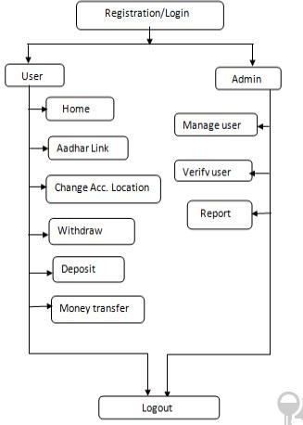

# Fig (A): Bank Management system

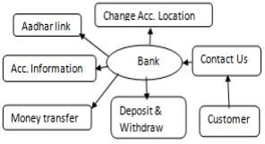

Fig. Mind map for bank management system

# SYSTEM ANALYSIS, RESULTS, AND DISCUSSION

Introduction:

System requirements analysis constitutes a comprehensive portrayal of the system's behavior that is to be developed. This encompasses a set of use cases that elucidate all

interactions between users and the system. Alongside use cases, system requirement analysis entails functional requirements, which outline the inner workings of the system, encompassing calculations, technical details, data handling and processing, and other precise functionalities that elucidate how use cases are to be fulfilled. Furthermore, it includes nonfunctional requirements, which impose restrictions on the design or implementation, such as performance benchmarks, quality standards, or design constraints.

**Requirements:**

The requirements serve as a thorough depiction of the system's behavior under development, encompassing both functional and nonfunctional requirements.

Functional Requirements:

Functional requirements detail the internal operations of the system, including calculations, technical specifics, data processing, and other specific functionalities that demonstrate how use cases are to be satisfied. These functionalities delineate the expected behaviors and actions of the system or its modules.

For the Admin Module:

1. The system enables admin login with a username and password.
2. The system permits the admin to input and manage Bank branch details.
3. The system empowers the admin to accept or reject manager/customer requests.
4. The system allows the admin to approve or reject customer transaction requests.
5. The system facilitates admin access to Managers & Customers' details.

For the Manager Module:

1. The system allows managers to register.
2. The system enables managers to log in using email and password.
3. The system empowers managers to accept/reject branch customer applications.
4. The system provides managers with access to view customer transactions.
5. The system allows managers to update their personal information.
6. The system allows managers to reset their password if forgotten.
7. The system allows managers to register new customers.

For the Customer Module:

1. The system enables customers to log in using email and password.
2. The system allows customers to update their personal details.
3. The system permits customers to reset their password if forgotten.
4. The system empowers customers to view their account balance.
5. The system allows customers to transfer money between accounts.
6. The system allows customers to recover their password.
7. The system enables customers to change their password.
8. The system allows customers to delete their profile.
9. The system enables customers to select image points for security.

Non-Functional Requirements:

Non-functional requirements specify criteria for evaluating the system's performance rather than specific behaviors. They are associated with how the system should be and dictate its quality. They primarily pertain to user satisfaction and include factors like the minimum acceptable page load time.

1. Integrity:

Integrity testing verifies the security of the application by checking for vulnerabilities and unauthorized access. It ensures that the information system safeguards data and functions as intended. For instance, this online banking application allows users to conduct transactions but prevents them from editing their account balance unless a transaction occurs.

1. Usability:

Usability testing involves identifying user problems and fixing them, particularly those related to the internal mechanisms of the product. This requires observation skills, patience, and openness to user suggestions.

1. Maintainability:

Maintainability testing assesses how easy it is to analyze, change, and test the application or product. It measures effort required for corrective, perfective, adaptive, and preventive maintenance. Maintainability involves the modular structure of software, internal program documentation, adherence to company standards, and coding guidelines.

In summary, the system's analysis reveals detailed requirements that encompass both functional and nonfunctional aspects, ensuring that the system is well- equipped to meet user needs while maintaining high standards of security, usability, and maintainability.

# System Architecture:

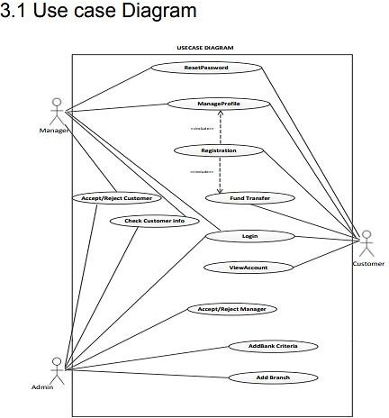

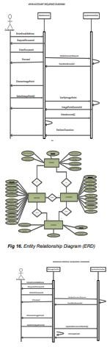

1. **Conclusion**

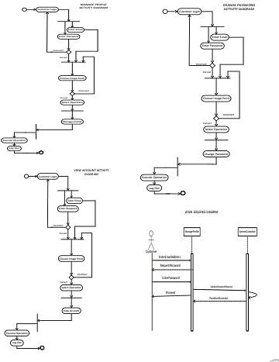I have effectively created and put into operation a Bank Customer Management system that enhances the security of managing customer information within banks. This system also fosters stronger relationships between banks and their customers by offering robust solutions that incorporate multi-level security measures to enhance customer satisfaction. I encourage fellow developers working on similar applications to carefully consider how they can contribute to the development of even more secure systems that address the challenges faced by the banking sector and other financial institutions in today's environment.

# Interface

**References**

* 1. 1. Fundamentals of database systems by (Elmasri Navathe, 2000), Website:https://archive.org/stream/FundamentalsOfDa tabaseSystemselmasrinavathe#

page/n51/mode/2up, Page: From 52 to more.

* 1. Article: Online banking, Website: https://en.wikipedia.org/wiki/Online_banking
  2. Online Bank Account Management System Website: [http://www.slideshare.net](http://www.slideshare.net/)
  3. Learning MYSQL, JavaScript, jQuery, PHP, HTML,

CSS3, Website: [http://www.w3schools.com](http://www.w3schools.com/)

* 1. PHP and MySQL video tutorial Durgasoft online.com
  2. Veneeva, V. (2006), “E-Banking (Online Banking) and Its Role in Today's Society”, Ezine articles

Python Durgasoftonline.com.